**The Course Project**

**Name: Sahithi Priya Rathod Kandanelly. Net.id: it7005**

**Plagiarism and cheating will not be tolerated for this individual and independent project assignment. All submissions will undergo a thorough plagiarism check. Sharing your work with other students, copying others’ work, or using AI tools such as ChatGPT is strictly prohibited. Any instances of plagiarism or cheating will result in a grade of 0 for the entire project submission.**

The course project consists of four parts. Parts 1, 2, 3 require the use of the project data zip file, while parts 4 require the use of a text file generated from part 3.

**Part 1:**

**Develop a Mapper and Reducer application to calculate the *average* of *wind direction* (degree) for *each observation month* *from each year* (e.g. 195001) from NCDC records (note: 999 indicates missing value, and [01459] indicate good quality value).**

1). Creating and executing python file the MRaverage.py file using *.gz

python MRaverage.py -r local *.gz

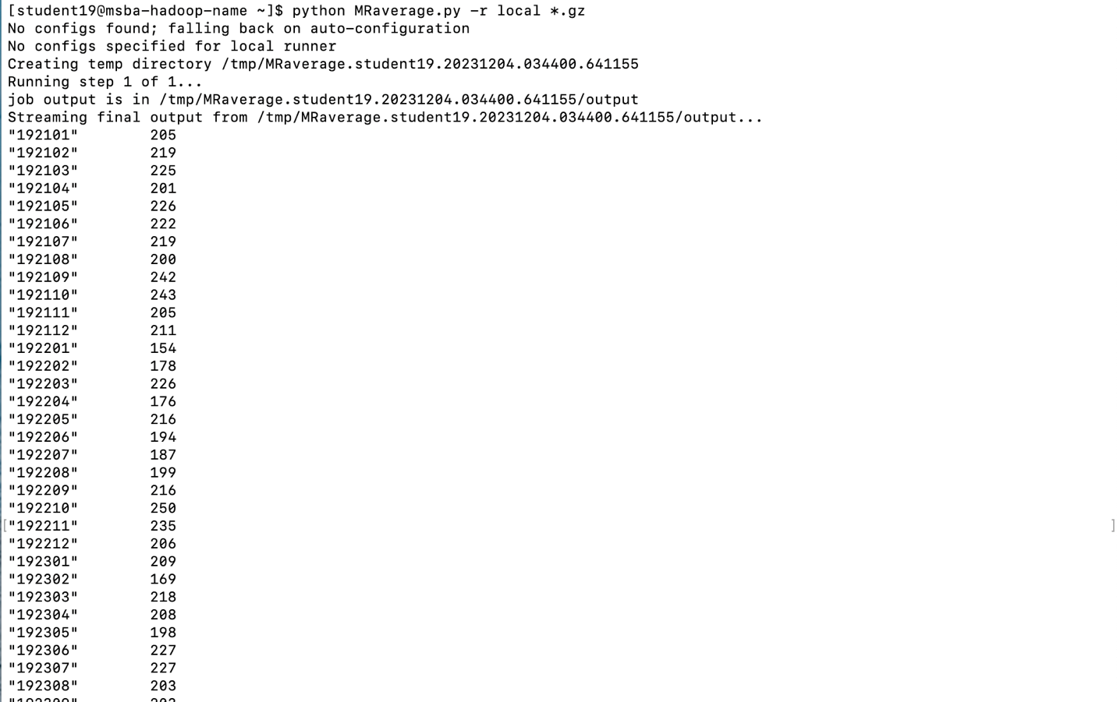

2). Writing the output to an output file python:

python MRaverage.py -r local *.gz --output-dir=./outputavg7/

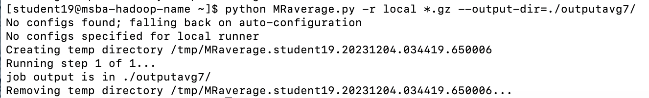

3). Output files:

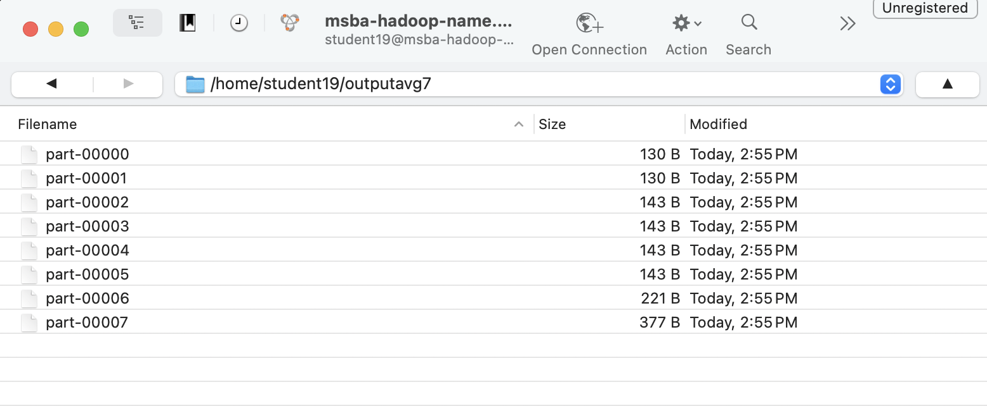

4). Running MRJob:

hdfs dfs -mkdir /home/19student19/inputavg7/

hdfs dfs -copyFromLocal *.gz /home/19student19/inputavg7/

hdfs dfs -ls /home/19student19/inputavg7

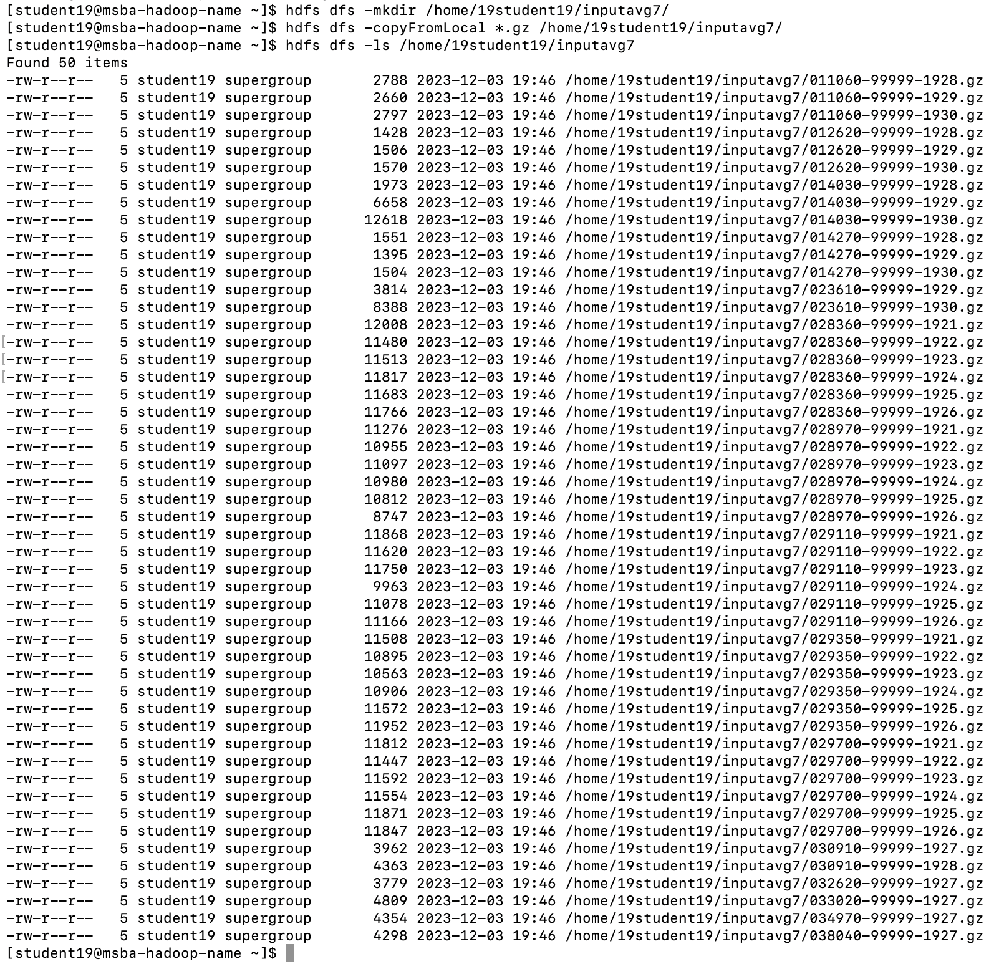

python MRaverage.py -r hadoop hdfs:///home/19student19/inputavg7/

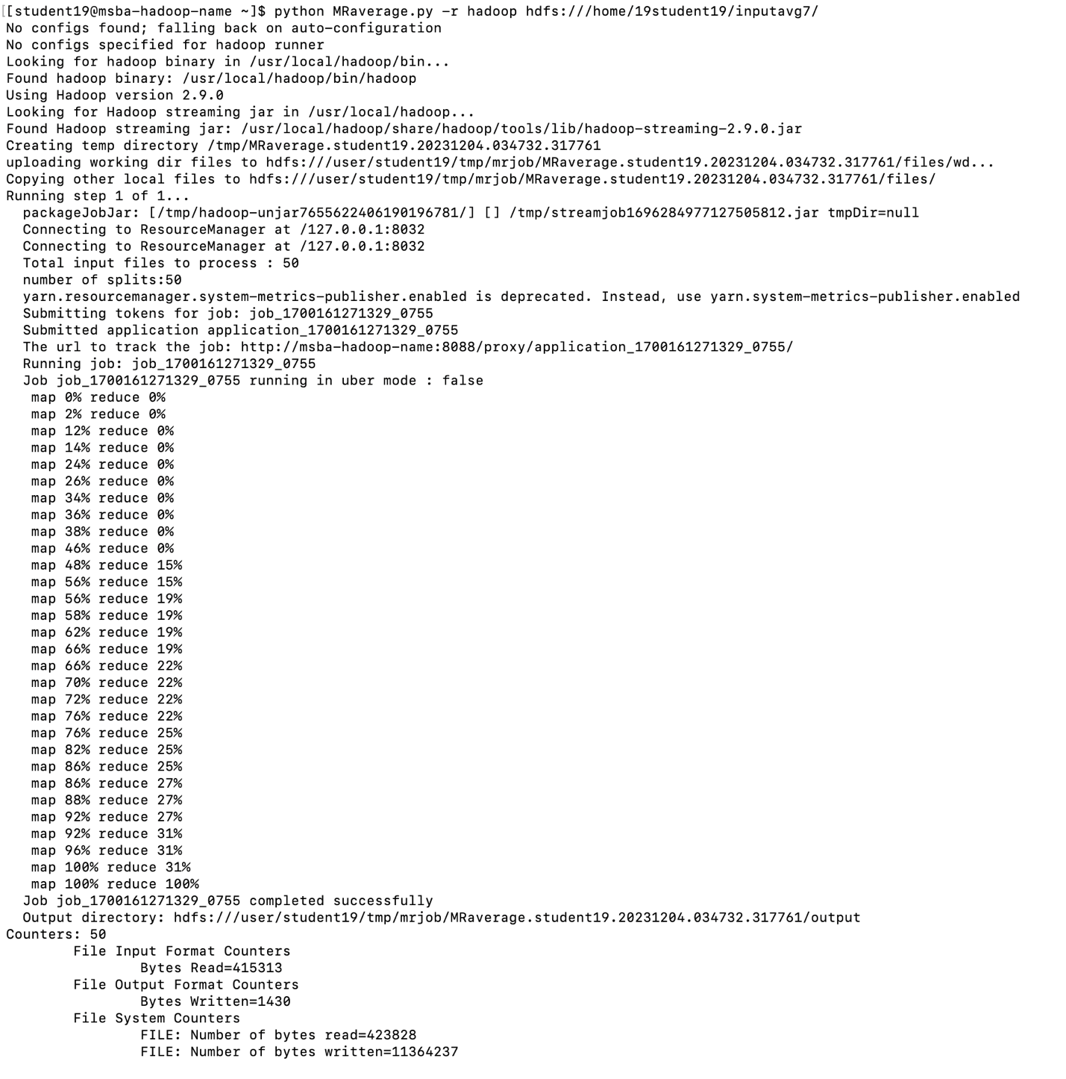

python MRaverage.py -r hadoop hdfs:///home/19student19/inputavg7/ --output-dir=hdfs:///home/19student19/outputavg19/

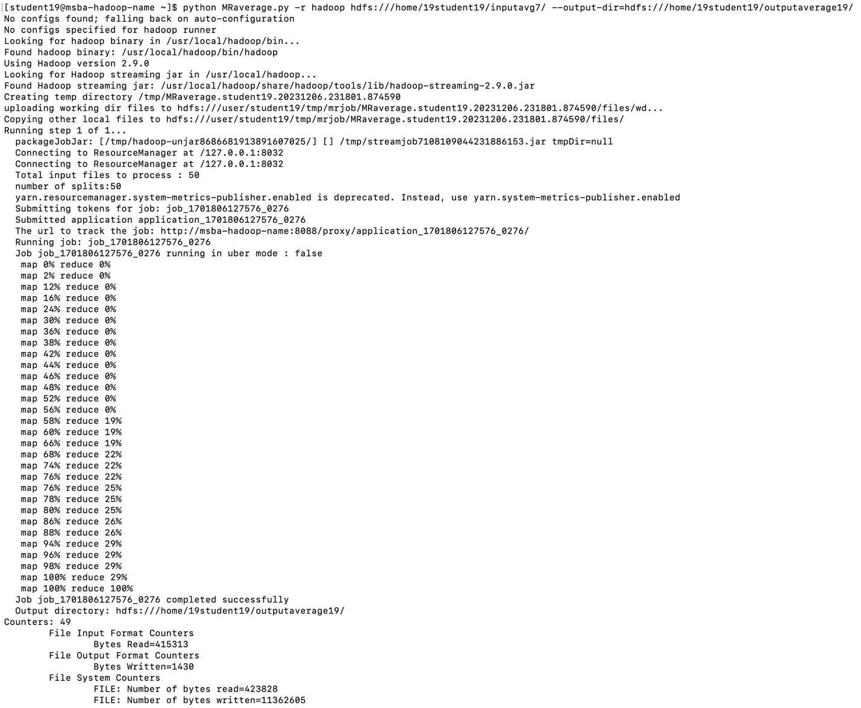

hdfs dfs -ls /home/19student19/outputavg19/

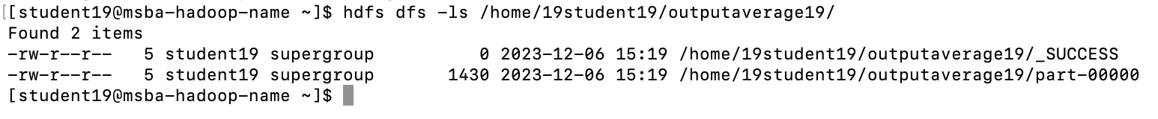

hdfs dfs -cat /home/19student19/outputavg19/part-00000

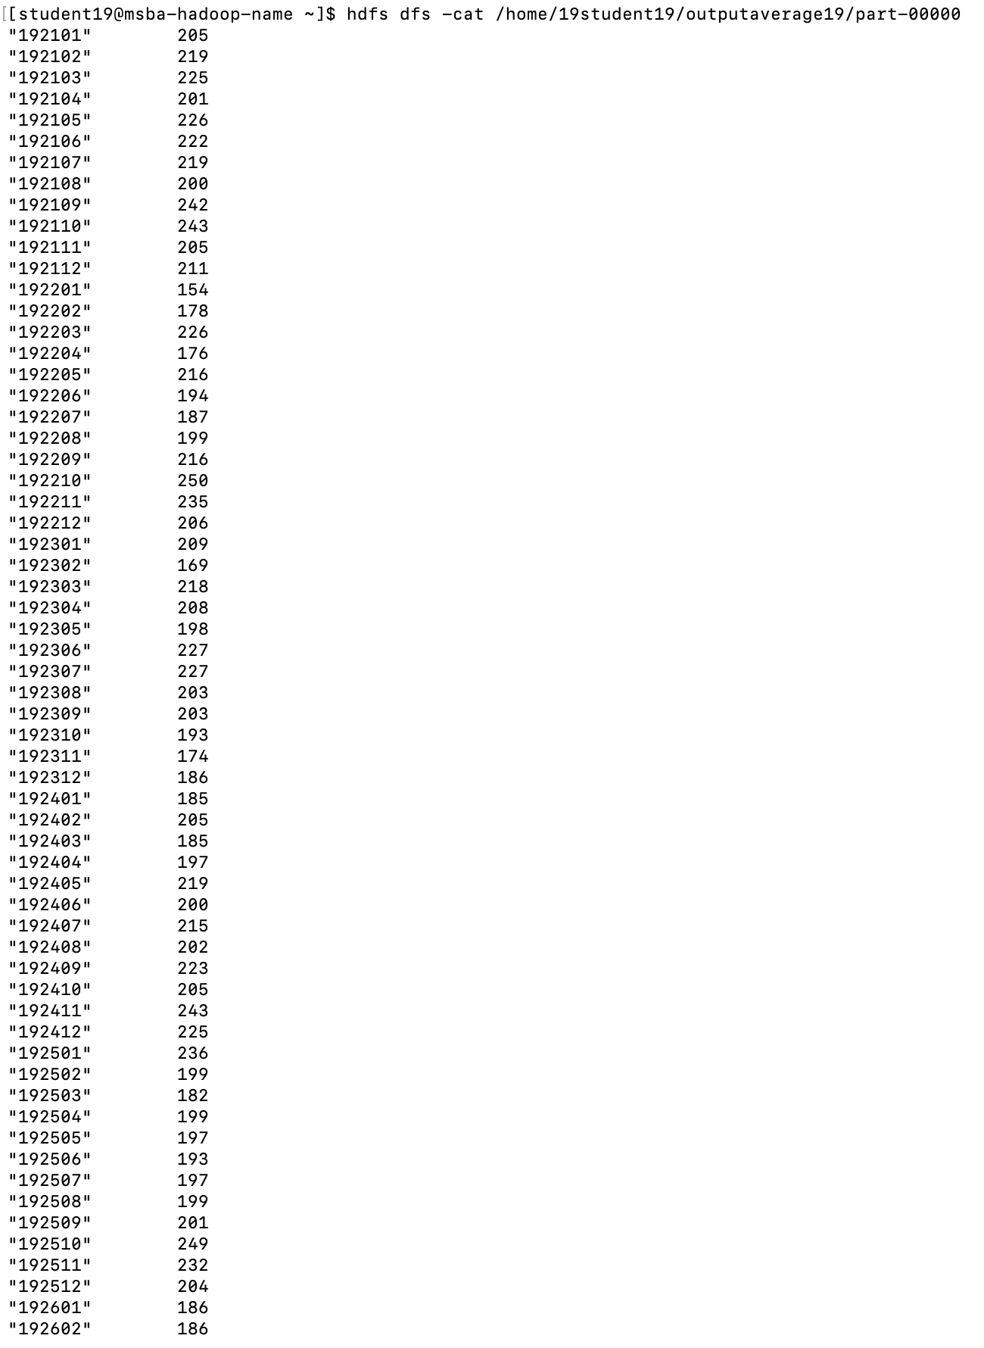

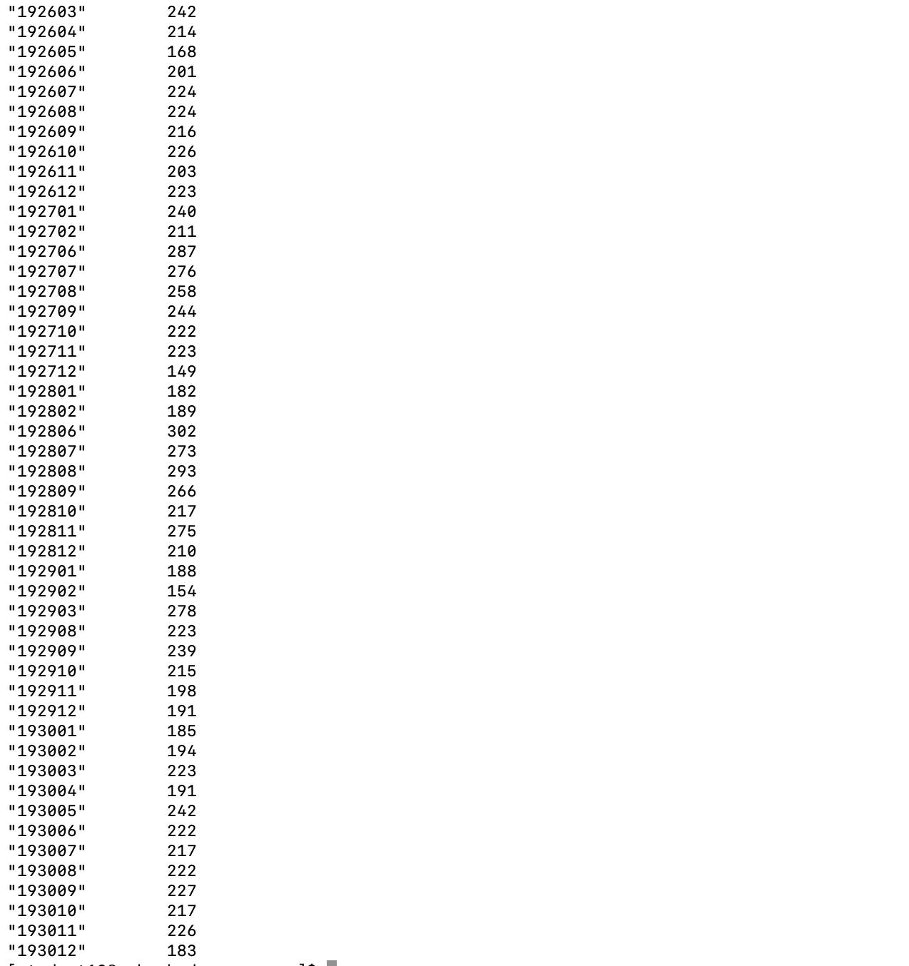

**Part 2:**

**Develop a python application that can be implemented in PySpark to calculate the *range* (the difference between max and min values) of *sky ceiling height* (meters) for *each USAF weather station ID* from NCDC records (note: 99999 indicates missing value, and [01459] indicate good quality value).**

hdfs dfs -ls /home/19student19

hdfs dfs -mkdir /home/19student19/inputheight

hdfs dfs -copyFromLocal *gz /home/19student19/inputheight

hdfs dfs -ls /home/19student19/inputheight

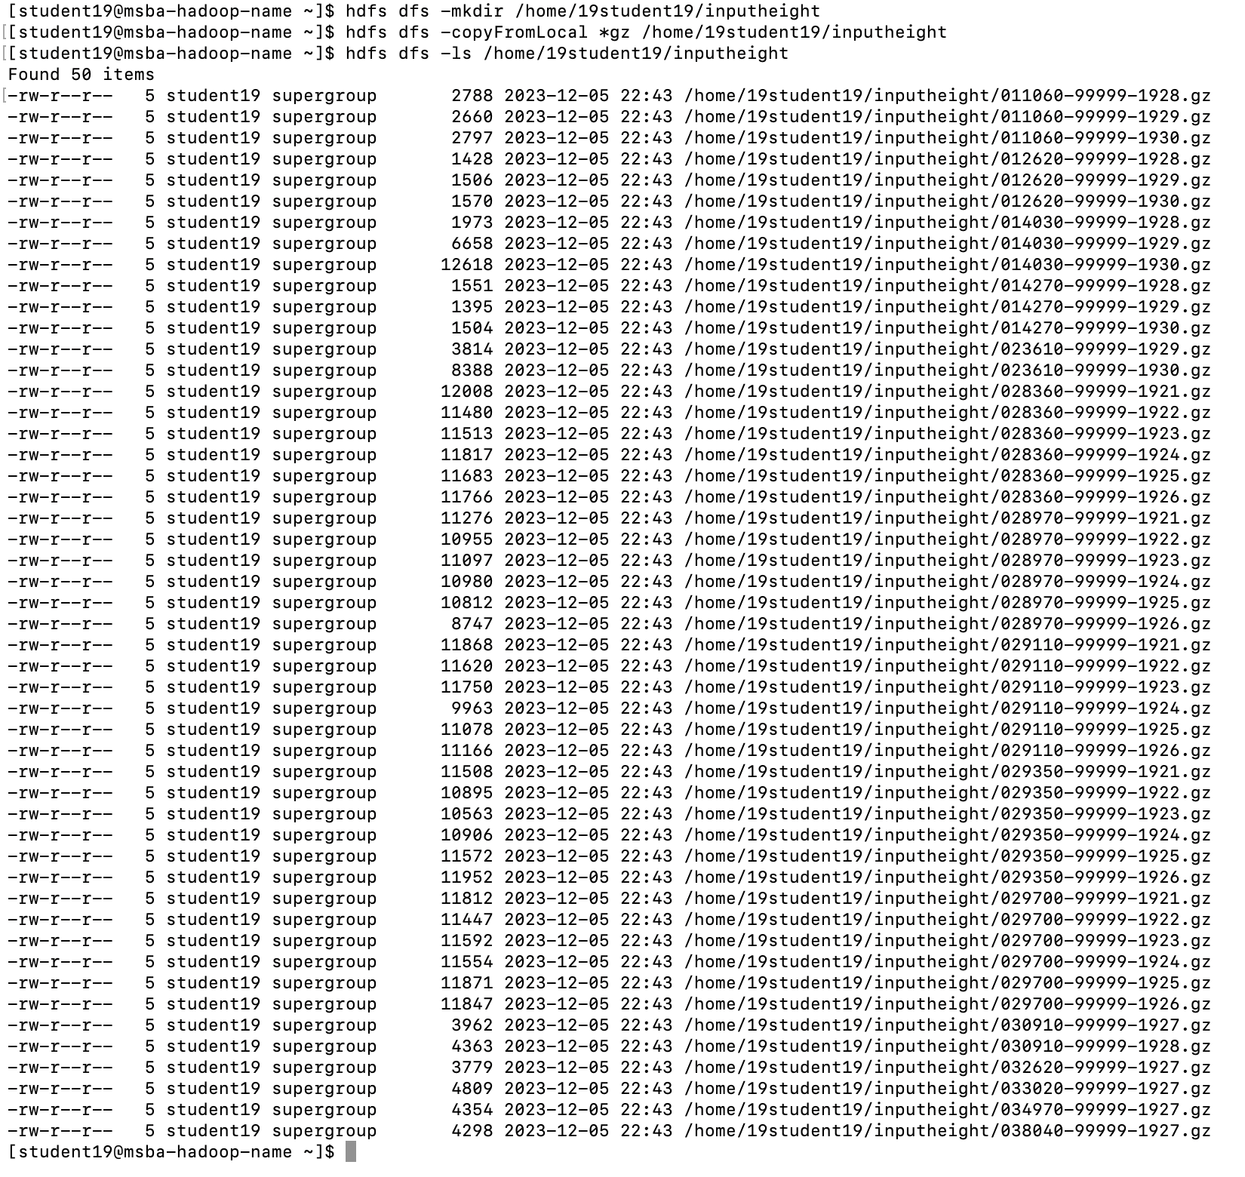

spark-submit --master local ceilingrange.py

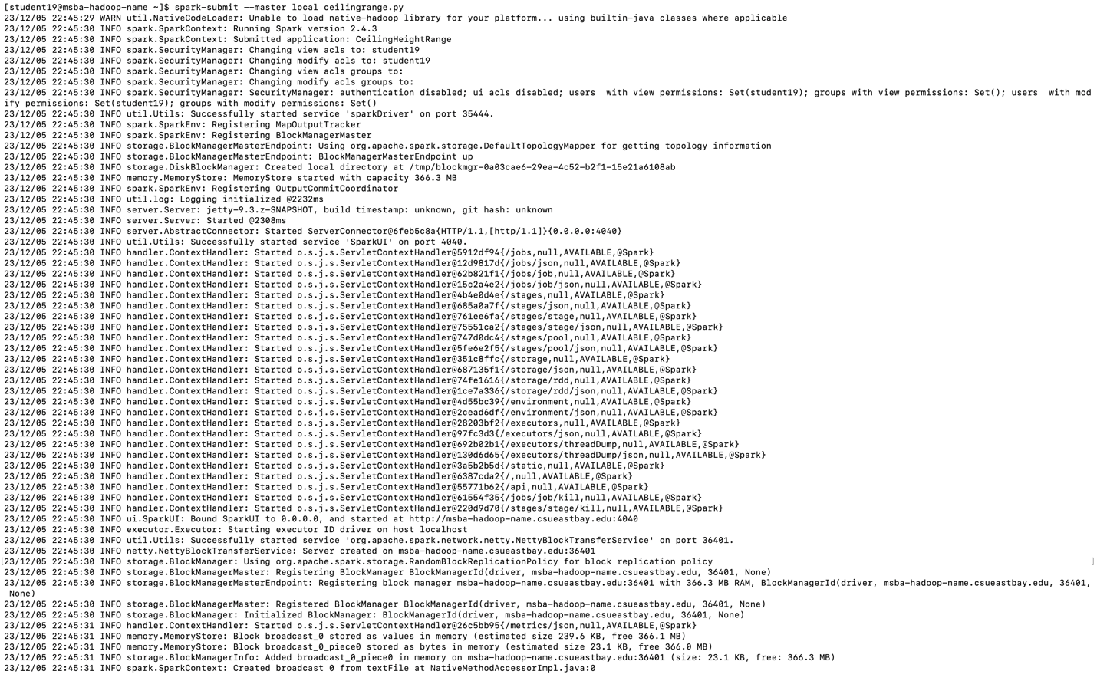

hdfs dfs -ls /home/19student19/outputheightrange

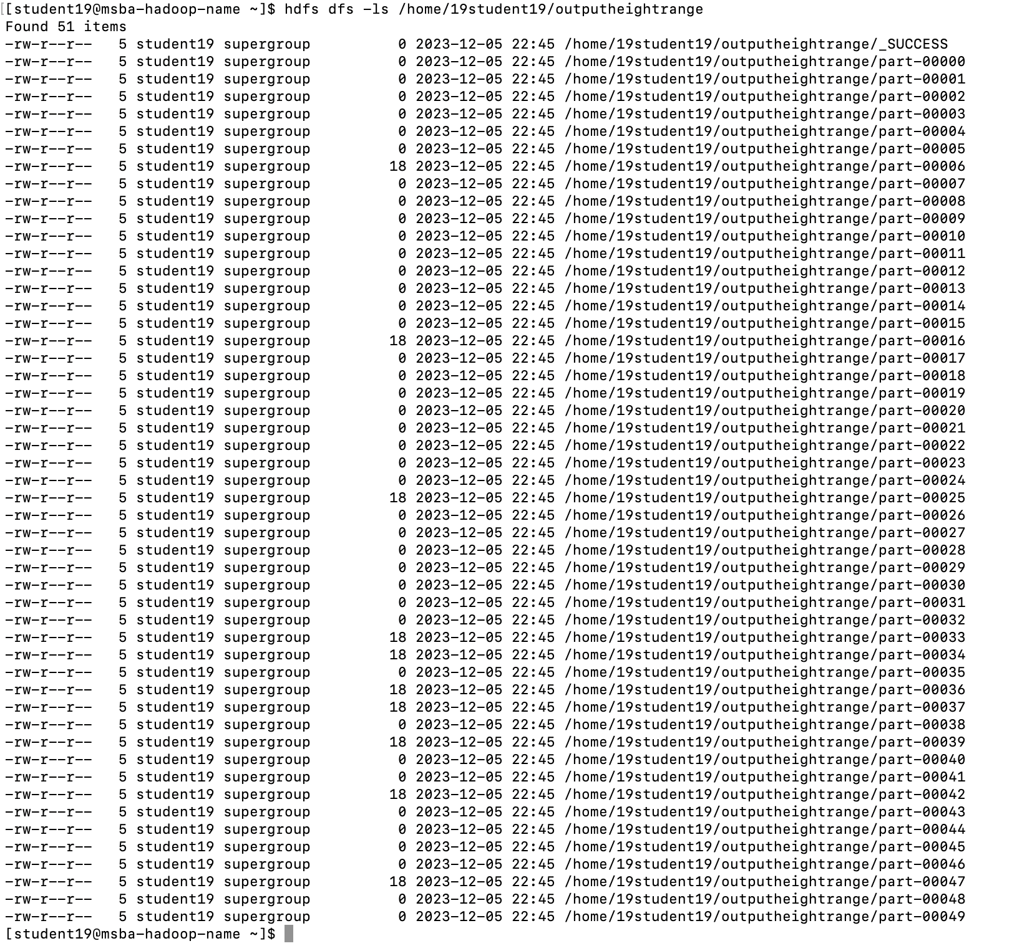

hdfs dfs -cat /home/19student19/outputheightrange/part-*

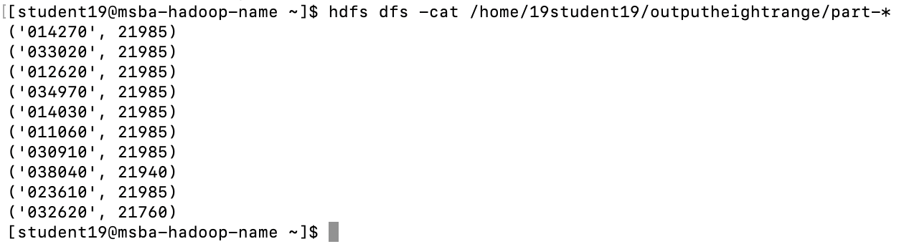

**Part 3:**

**Develop a Mapper and Reducer application to retrieve *USAF weather station ID* and *visibility distance (meters)* from NCDC records (note: 999999 indicates missing value, and [01459] indicate good quality value) and then *write* the USAF weather station ID and visibility distance data into *a text file*.**

1). Creating and executing python file the Recordsdata.py file using *.gz

python Recordsdata.py -r local *.gz

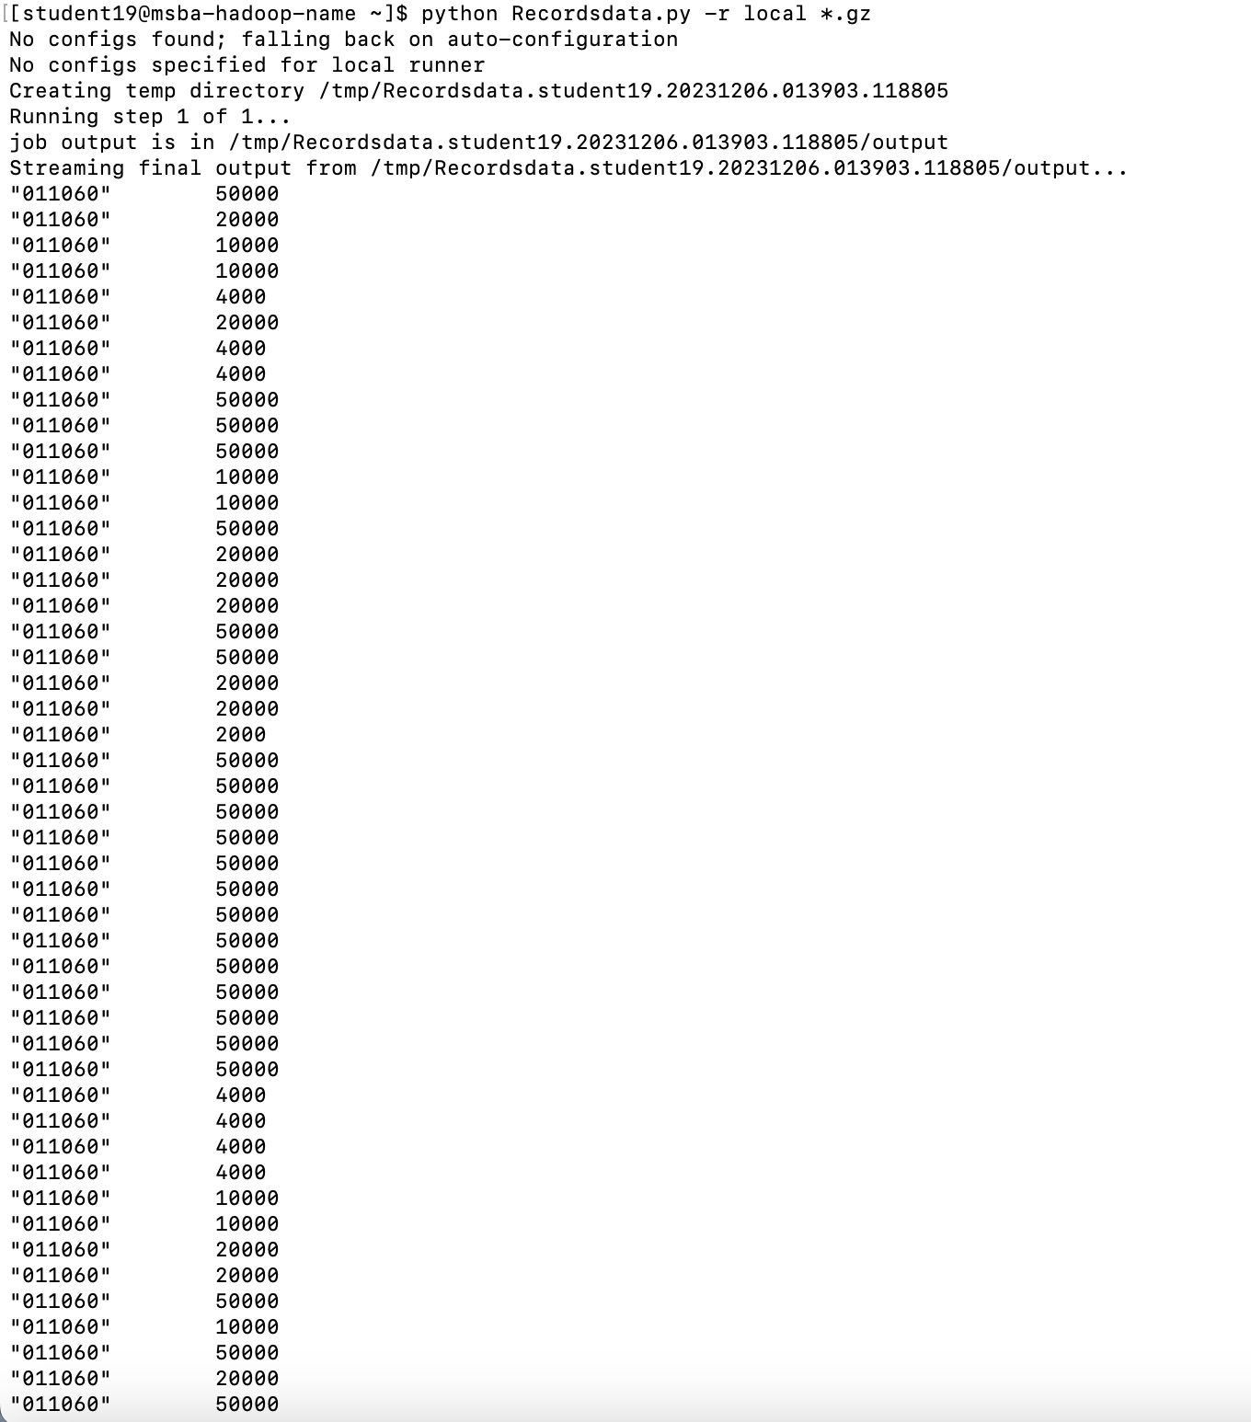

2). Writing the output to an output file python:

python Recordsdata.py -r local *.gz --output-dir=./outputrecords/

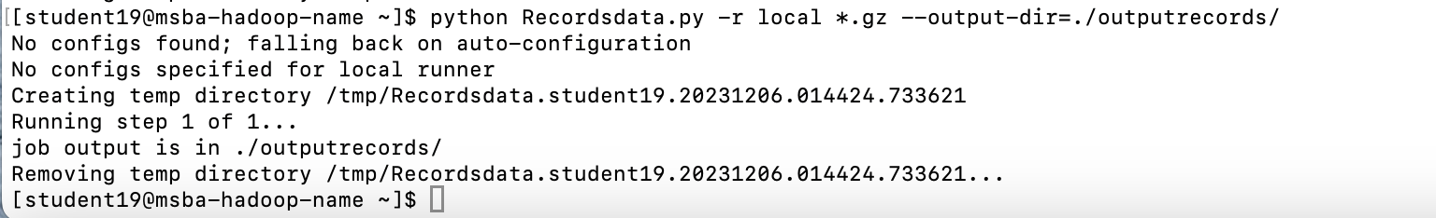

3). Output files:

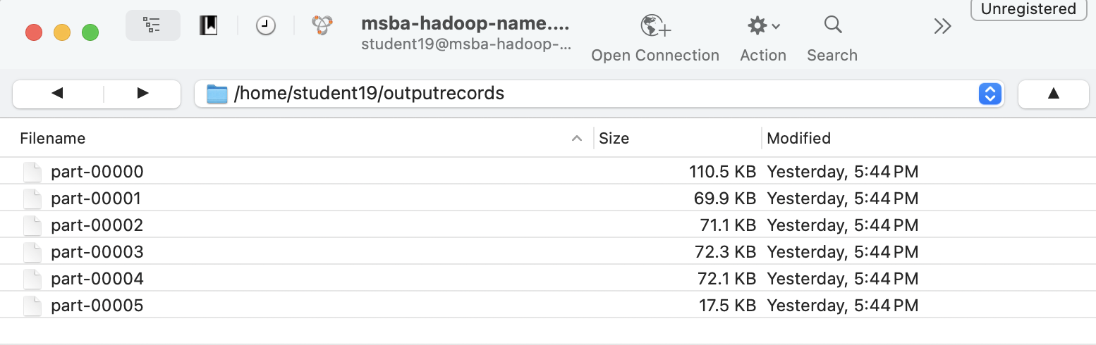

4). Running MRJob:

hdfs dfs -mkdir /home/19student19/inputrecords/

hdfs dfs -copyFromLocal *.gz /home/19student19/inputrecords/

hdfs dfs -ls /home/19student19/inputrecords

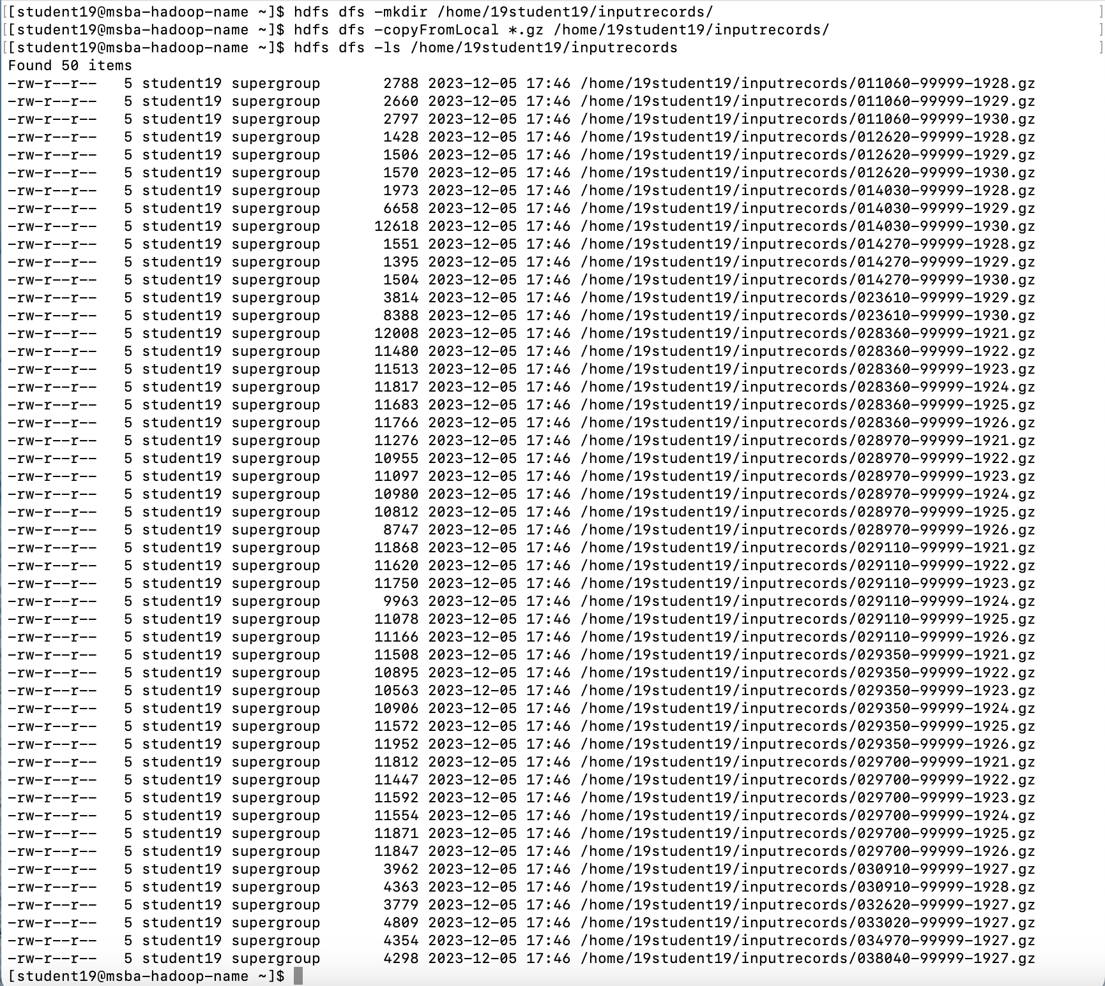

python Recordsdata.py -r hadoop hdfs:///home/19student19/inputrecords/

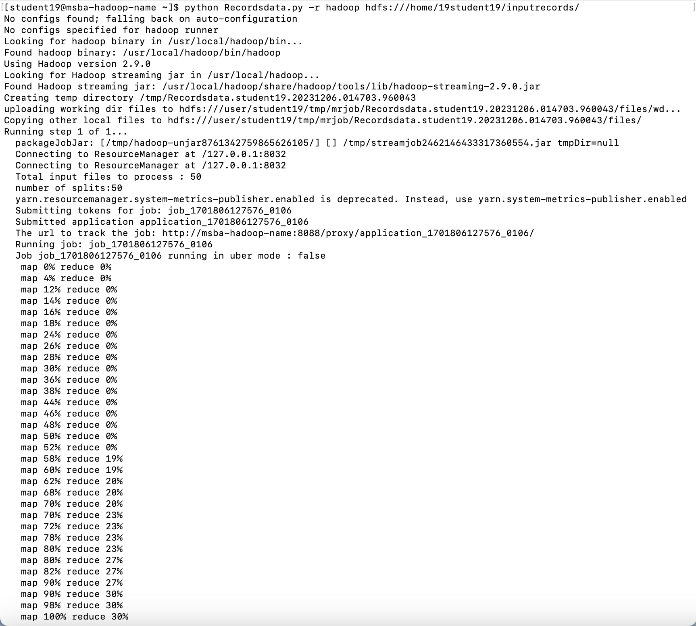

python Recordsdata.py -r hadoop hdfs:///home/19student19/inputrecords/ --output-dir=hdfs:///home/19student19/outputrecords1/

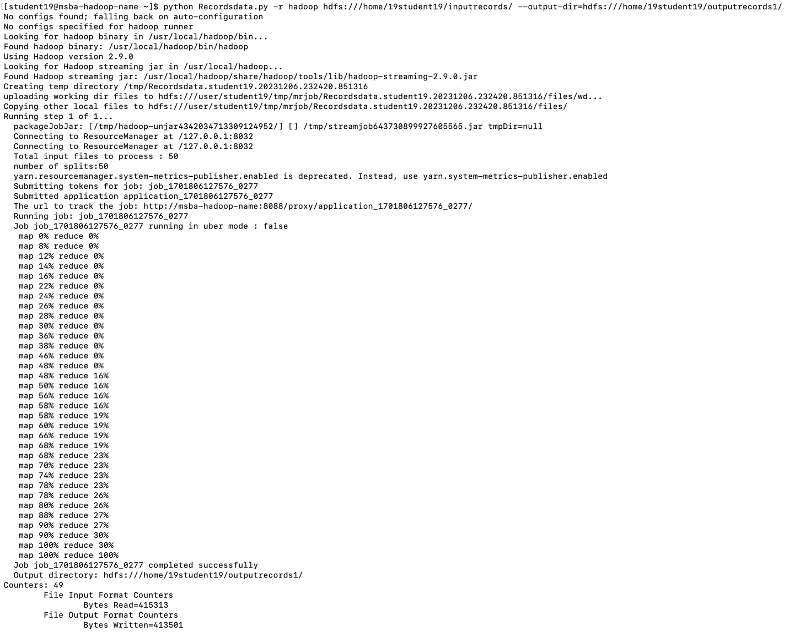

hdfs dfs -ls /home/19student19/outputrecords1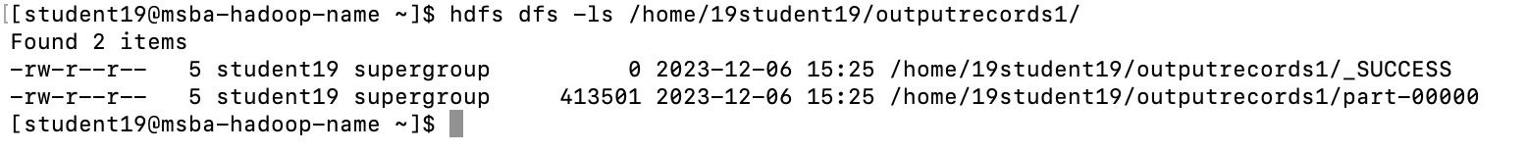

hdfs dfs -cat /home/19student19/outputrecords1/part-00000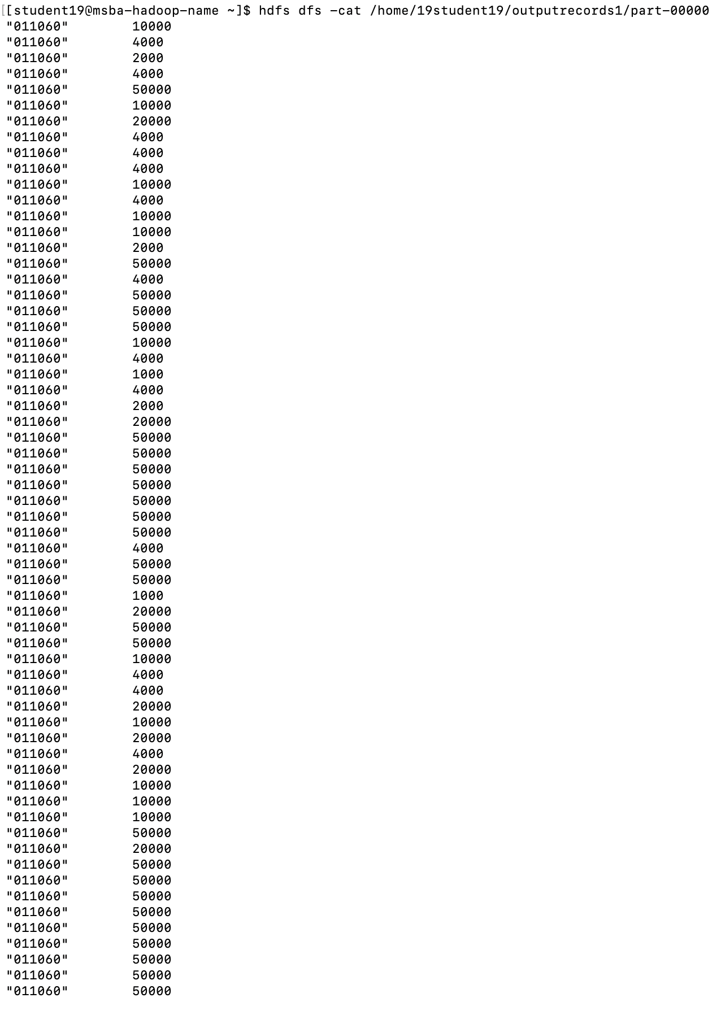

hdfs dfs -get /home/19student19/outputrecords1/part-00000 RECORDSDATA.txt

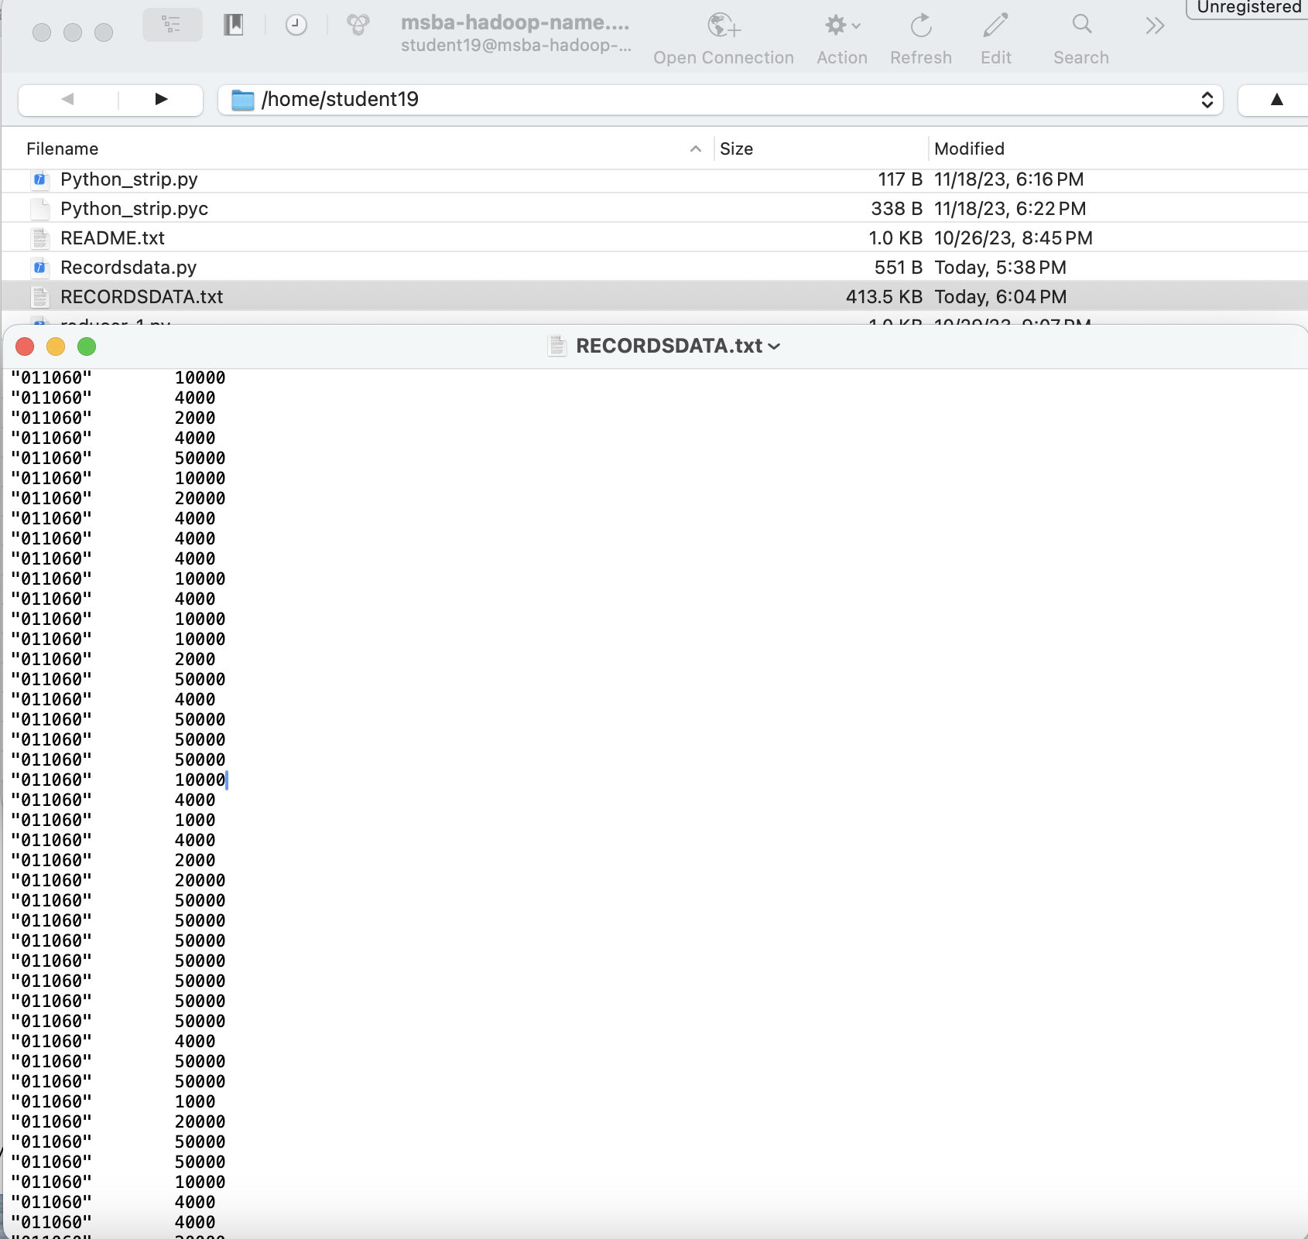

**Part 4:**

**Load the text file into Pig and get the range of *visibility distance* for each USAF weather station ID.**

pig -x local

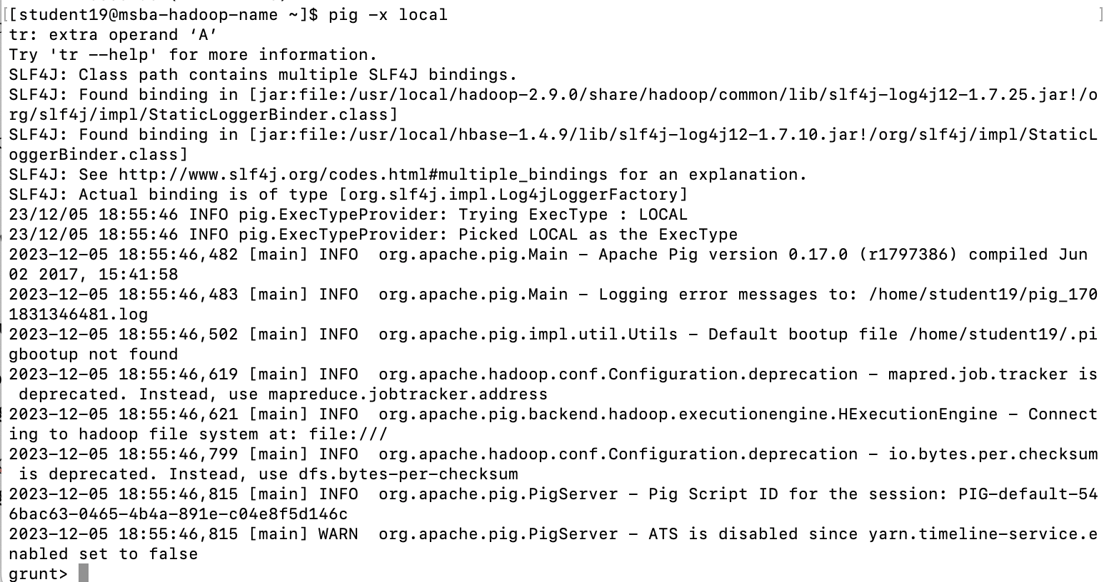

data = LOAD 'RECORDSDATA.txt'

>> AS(station_id:chararray, visibility_distance:int);

grouprecords = GROUP data BY station_id;

Range = FOREACH grouprecords GENERATE group,

>> MAX(data.visibility_distance)- MIN(data.visibility_distance);

DUMP Range;

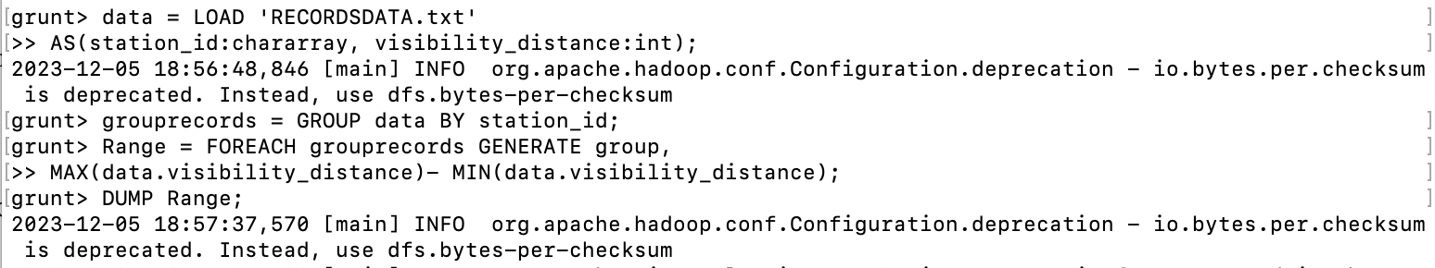

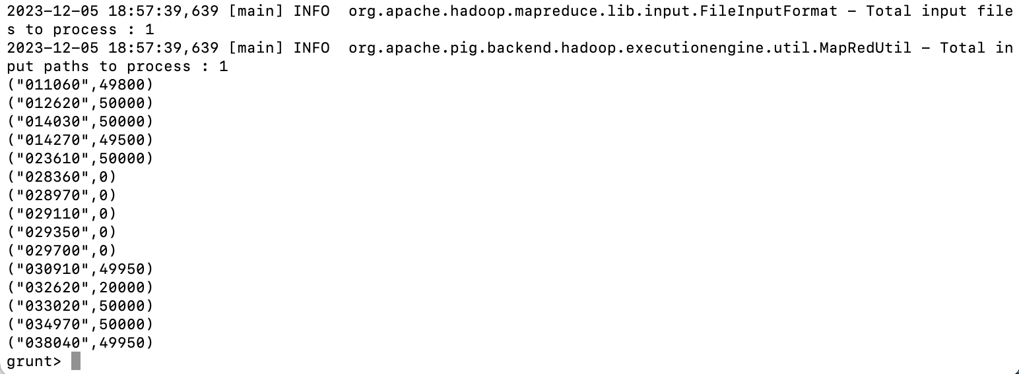

**Load the text file into Hive and get the average *visibility distance* for each USAF weather station ID.**

hive

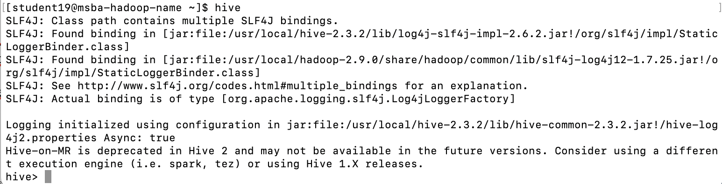

hive> CREATE TABLE recordsdata_19 (station_id STRING, visibility_distance INT)

> ROW FORMAT DELIMITED

> FIELDS TERMINATED BY '\t';

hive> LOAD DATA LOCAL INPATH 'RECORDSDATA.txt'

> OVERWRITE INTO TABLE recordsdata_19;

hive> SELECT station_id, AVG(visibility_distance) FROM recordsdata_19 GROUP BY station_id;

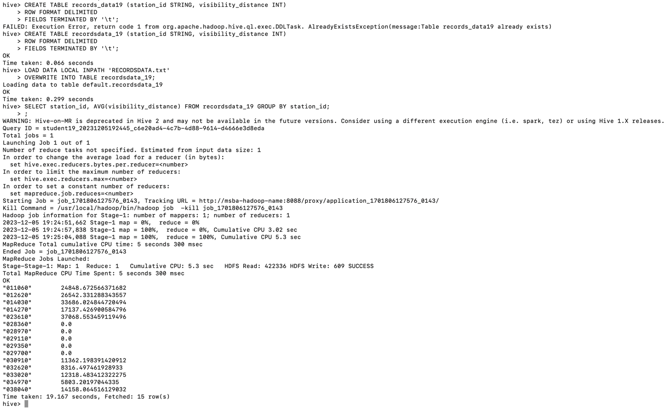

**You need to turn in:**

**1)** Part 1:

a. *if you are using JAVA to develop the Mapper and Reducer applications:* the three java files (mapper, reducer and main);

b. *if you are using Hadoop streaming jar and developing two python programs (mapper python file and reducer python file)*: the two python files (mapper and reducer);

c. *if you are using mrjob library and developing one python program with two functions:* the python file (with the mapper and reducer functions);

2) Part 2: the python program you developed;

3) Part 3: refer to Part 1; and the text file created;

**4)** the commands from converting java files into a Jar file to running the Jar file in Hadoop, or the commands to execute the python files in Hadoop and in Spark, all commands in Pig and Hive;

**5)** the step by step commands and screenshots of solutions from all the parts;

The original dataset for this project is available on Canvas.